Beyond the Cards
Alex Shvartsman
Sometimes a "correct" play is not the right one to make.
The idea to write this article came to me when chatting on IRC (Internet Relay Chat) with a friend who described his Magic skills in a very eloquent way. "I am good at playing against the cards. I am not as good at playing against the people."

What gives top pros their edge?
He went on to explain how he is able to defeat seasoned PT veterans when playing them online, but usually loses hard to the same players in actual games of Magic.
I began pondering what makes a player good. Making technically correct plays is an acquired skill that, despite taking some serious time and effort to muster, is accessible to great many players. So what gives top pros their edge? The answers, in my opinion, are flexibility and imagination.
A master player will often find a way to defeat his opponent or at least gain an advantage where a less imaginative player might not. Often this is achieved by making a counterintuitive play or simply bluffing.
A very common bluff that you are likely familiar with is always leaving two blue mana untapped when you play a control deck. You may or may not actually hold a Counterspell, but your opponent will be forced to consider the possibility that you have one. A slightly better bluff is to only leave one Island and some Plains untapped if you actually have a Power Sink or Prohibit. An opponent will likely try to cast his best spell while you do not have a second Island available, and walk right into your set up.
Here is a better example that combines an art of the bluff with playing the psychological game:
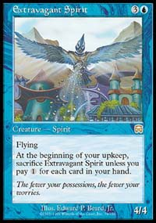
You are playing a Masques Block Limited game. In play, you have a pair of 2/2 creatures, and your hand contains lands and creatures only. Your opponent just cast Extravagant Spirit - a 4/4 flying creature that you have very few ways to deal with in your deck. The Spirit will begin attacking next turn, but it also shuts down your offense while it is summon-sick.
A technically correct play is to cast a creature and end your turn. Obviously dealing two points of damage to your opponent is not worth losing one of your two creatures. But is it the RIGHT play?
A top tier player will often decide to attack with both creatures anyway. His opponent is now in a difficult position. On one hand he could block and take out a 2/2 for free. On the other hand, this opens his Extravagant Spirit to being removed by a much greater number of spells. For example, Seal of Fire or Invigorate could remove the Spirit if it blocks, yet those cards are not going to be able to stop it otherwise.
How do you know when to block and when to take the damage? A good player will almost always take the damage if it is early in the game and he feels that those two points will not be crucial. Yet those two points MIGHT make a difference between winning and losing the game, as the ground creatures race against the flier.
Attacking in this situation is risky. Your opponent may be a weaker player and simply block regardless of other considerations because his understanding of the game is not very deep. On the other hand, your opponent might be good enough to see through your ploy and call your bluff.
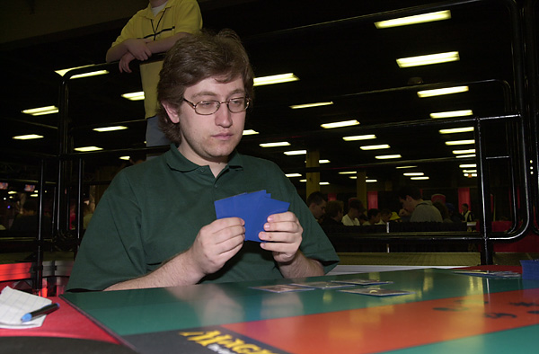
I found myself in a perfect situation to exercise my bluffing skills recently. I was playing Invasion Sealed Deck at Grand Prix: Manchester. I was in a damage race against British player Ellis Romero, and the situation looked grim. I was going to die in two turns, and had very few cards left in the deck that could change that. On the other hand, I would beat Ellis if I could only buy myself one more turn. Time was running out, but we would easily finish the game one way or another during the extra turns, and so I took my time to think about the situation.
In the end, I decided that a gamble would be worthwhile. I attacked with all of my creatures. Although this would not allow me to actually win the game that turn, it would bring Ellis' life total really low. Problem is, this left me with no blockers and Ellis could easily counterattack on his own turn to kill me. It was now Ellis' turn to think hard. I can imagine exactly where his thought process was headed. "Surely, Alex realizes that I can kill him next turn. That could only mean one thing - he plans on winning before then. He must either have a combat trick of some sort or a direct damage spell, and I must stop some of the creature damage in order to stay alive."
My desperation attack convinced Ellis to block and trade some creatures, including one of the two monsters that would have finished me in two turns. Had I played it safe, there was a small chance I would draw something on the following turn to help me win (as it turns out, my next card was a land). There was an even better chance that Ellis would simply not buy into my attack and opt to risk losing to whatever trick I was holding in order to have a chance of winning on the following turn. But I felt the gamble was well justified, and it won me the game I would have surely lost otherwise.
Successfully bluffing your opponent does not always involve cards that are on the table.
Randy Buehler, one of the game's all time greats, often recalls the first time he met Ben Rubin in a Pro Tour match. With plenty of money on the line, Buehler was keeping a close eye on then-unknown Rubin, hoping to discern the quality of his draws based on Rubin's behavior, body language and facial expressions. Rubin drew a removal spell he needed, but did not betray this to his opponent. Instead, he sort of frowned just a little, knowing that Buehler would catch it and interpret it wrongly. Buehler did in fact fall for Rubin's ploy and ended up losing the game because of that.
This is an example of a game played at the highest level. Had Buehler ignored Rubin and played based on the technical information only, he may have ended up winning that game. Yet he probably would not have made it far enough to compete with Rubin for a Top 8 spot had he not successfully "read" his opponents earlier in the tournament.
Within every game of Magic you play lie countless opportunities. Just how many of those opportunities you will recognize and use against your opponent might be the defining factor of your ability as a Magic player.

